Name : Lakhan Kumawat

Roll No : 1906055

Branch : CSE-1

Course : CS4403

LAB Experiment 08

To implement Floyd-Warshall algorithm and show the output:

**Program Code :**

#include<iostream>

#include<vector>

#define INT_MAX 10000

using namespace std;

vector<vector<int> > floyd_warshall(vector<vector<int>> graph){

vector<vector<int>> dist(graph);

int v=graph.size();//vertices in the graph

for(int k=0;k<v;k++){

for(int i=0;i<v;i++){

for(int j=0;j<v;j++){

if(dist[i][j]> dist[i][k]+dist[k][j]){

dist[i][j]=dist[i][k]+dist[k][j];

}

}

}

}

return dist;

}

int main(){

//4 vertices (4x4 matrix basically)

vector<vector<int> > graph={

{0,3,INT_MAX,7},

{8,0,2,INT_MAX},

{5,INT_MAX,0,1},

{2,INT_MAX,INT_MAX,0}

};

cout<<"After Applying Shortest distance Floyd Warshall Algorithm : "<<endl<< "Matrix : 1 2 3 4 "<<endl;

auto result = floyd_warshall(graph);

for(int i=0;i<result.size();i++){

cout<<" "<<i+1<<" ";

for(int j=0;j<result.size();j++){

cout<<result[i][j]<<" ";}

cout<<endl;

}

return 0;

}

Given Graph :-

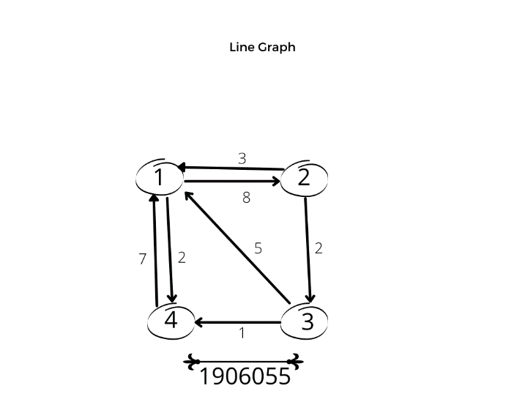

**Output : -**

